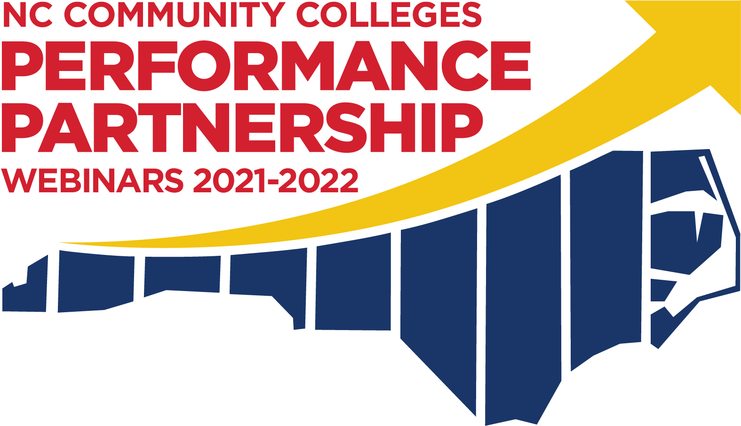

NCCC System Best Practice 2022 Webinar sessions
All Webinars will begin at 3:00 pm and last until 4:00 pm

February 17, 2022
Promising Practices to Close Dual Enrollment Access Gaps
This webinar will be a panel discussion on promising practices and relevant topics related to closing demographic access gaps to the Career and College Promise (CCP) program. Panel includes representation from colleges with some of the state's smallest CCP access gaps.

- McKenzie Burk, Career Coach, Piedmont CC
- Jennifer Welch-Jones, Northampton County Early College Liaison, Halifax CC
- Michelle Lair, Career and College Promise and CTE Coordinator, NCCC System

Please register at: https://attendee.gotowebinar.com/register/2357733779511419660
After registering, you will receive a confirmation email containing information about joining the webinar.

March 17, 2022
Promising Practices for Minority Student Recruitment
This webinar will be a panel discussion on promising practices and relevant topics related to marketing and recruitment efforts geared towards expanding higher education access for minorities.
- Melissa Sykes, Coordinator of Recruiting, Nash CC
- Natasha Lipscomb, VP Student Success Services, Rowan-Cabarrus CC
- Kali Brown, Dean of Student Access and Support, Vance-Granville CC
- Amber Ferrell, Counselor, James Sprunt CC
- Monty Hickman, Associate Director for Enrollment Management, NCCCS
Please register at: https://attendee.gotowebinar.com/register/2893298196819801356

April 14, 2022
Promising Practices to Close Equity Gaps Associated with Student Completion
This webinar will be a panel discussion on promising practices and relevant topics related to closing completion equity gaps across demographic groups. Panel includes representation from colleges with some of the state's smallest equity gaps associated with the four-year graduation and/or transfer rate.
- Candice Solis, Director of Student Success, University Transfer and Advising, Central Carolina CC
- Erica Caracoglia, Dean of Institutional Effectiveness, Beaufort County CC
- Michael Hall, Student Success Coach, James Sprunt CC
- Lisa Eads, Associate Vice President of Programs, NCCCS
Please register at: https://attendee.gotowebinar.com/register/5543334525015826188

June 16, 2022
Personas Project: Personifying Student Data to Improve Performance
This webinar will present a broad-based project for understanding our students. The IE staff summarized all students the college served by creating student profiles. In addition to summary data, these profiles included names and short descriptions. The profiles have spurred discussions for the college's equity team and marketing research despite being released during the pandemic.
- Kim Sandoval Institutional Research and Assessment Specialist, South Piedmont CC
- Christine Teach, Institutional Research Analyst, South Piedmont CC
Please register at: https://attendee.gotowebinar.com/register/145518583449587724

Performance Partnership Committee Members
Katie Bao, Research Specialist, NCCC System
Jenny Billings, Chair of English, Developmental English and ACA, RCCC
Evonne Carter, Chair of Committee, Vice President of Learning, COA
JJ Evans, Associate Director of Student Life, NCCC System
Onya Gardger, Dean of Continuing Education and Workforce Development, BCC
Deana Guido, Director of Academic Programs, NCCC System
Sondra Hines, Program Coordinator – College & Career Readiness, CPCC
Susan Huneycutt, Dean, Arts and Sciences; Business and Technology, DDCCC
Michelle Lair, CCP & CTE Coordinator, NCCC System
Daniel Loges, CCR - Director Professional Dev and Distance Education, NCCC System
Karen Tikkanen, Director for Workforce Con Ed Training & Standards, NCCC System
Linda Scuiletti, Vice President of Assessment, Planning and Research, CCCC
Jimmy Smith, Director of Faculty Training and Development, Wake Tech

