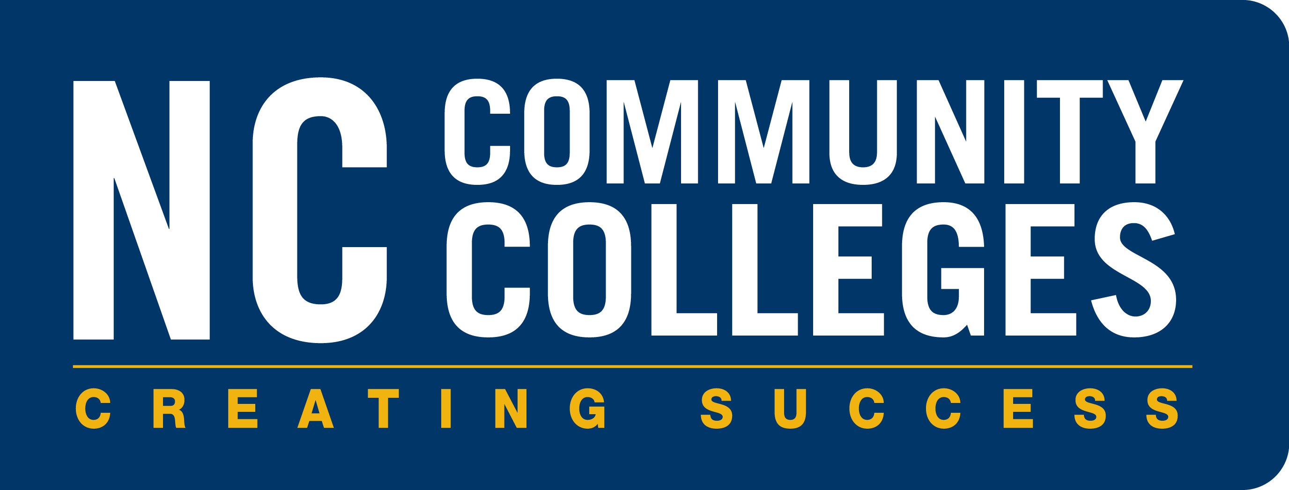
NCCCS Advising & Student Support Redesign
Training Webinars for College Liaisons
College Advising Liaisons will be invited to participate in training in best practices in each of the key framework elements on the following dates:

Intrusive Advising May 23 2:00 p.m.

Career Planning June 13 2:00 p.m.
https://register.gotowebinar.com/register/1803285221886212609

Academic Planning July 18 2:00 p.m.
https://register.gotowebinar.com/register/7812561569891441921

Financial Planning August 29 2:00 p.m.
https://register.gotowebinar.com/register/2434907373043677185

Timely Communication September 12 2:00 p.m.
https://register.gotowebinar.com/register/7254383496934712065

Integrated Support & Interventions October 17 2:00 p.m.
https://register.gotowebinar.com/register/952642553499353345

Transfer Advising November 7 2:00 p.m.
https://register.gotowebinar.com/register/1738478907033654529

These webinars will be recorded and made available in Moodle and linked on the System Office website for liaisons to share with colleagues at each institution.
For more information or to register, contact Daniel Alvarado at alvaradod@nccommunitycolleges.edu

